

Fountaindale School
an academy within Nexus MAT

Nottingham Road, Mansfield, NG18 5BA
Tel: 01623 792671
Email: fountaindaleschool@nexusmat.org
Website: www.fountaindaleschool.org
Contact: fountaindaleschool@nexusmat.org

Fountaindale SEND Toddler Group
Does your child have special educational needs or disabilities? Come and join us for our SEND toddler group on the second and last Friday of each month.
10 – 11:30
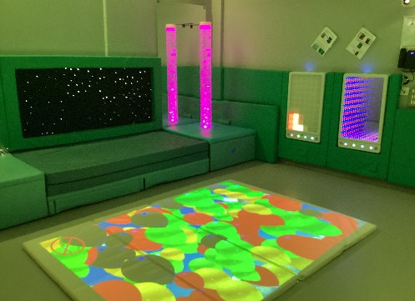
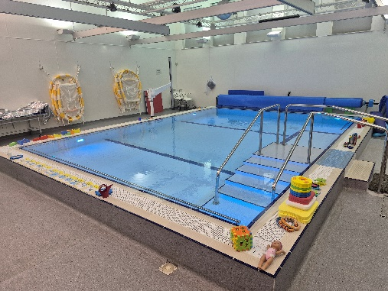

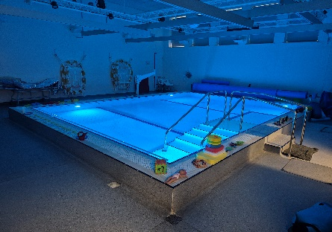
Please ring 01623 792671 to express your interest.
Toddler and parent swims
Make friends
Sensory room sessions



*Please note, groups will not run during school holidays.
Your child does not need an official diagnosis or EHCP to attend.
Siblings welcome

