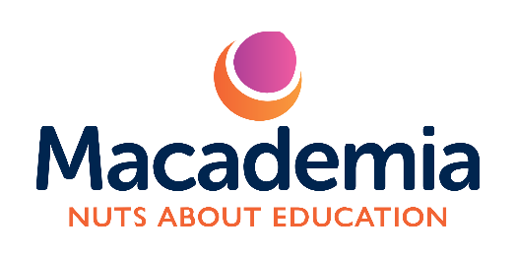
Macademia Ltd Privacy Policy

Last updated: October 2025

At Macademia Ltd (“we”, “our”, “us”), your privacy is extremely important to us.
This policy explains what personal information we collect, why we collect it, and how we protect it when you interact with our services — including bookings, workshops, courses, events, and communications.

We are committed to keeping all data safe, secure, and used only for the purposes you would reasonably expect.

1. Who We Are

Macademia Ltd
Registered in England & Wales
Registered Address: 702 Moor Road, Nottingham, NG6 8TD
Email: info@macademia.co.uk

Website: www.macademia.co.uk

We are an educational provider offering creative, academic and professional development courses for children and young people.

2. The Information We Collect

We may collect and process the following personal information:
For parents and guardians:
Name, email address, postal address, and phone number
Payment details (processed securely through third-party providers)
Communication preferences and correspondence history
For students/children (via parent/guardian consent):
Full name, date of birth, age, and school year
Medical information or allergies (to ensure safety during sessions)
Emergency contact details
Photos or creative work (only with explicit consent)

3. How We Use Your Information

We use your personal information to:
Process bookings and payments
Communicate important course or session updates
Ensure the safety and wellbeing of all children during our sessions
Send invoices, receipts, or confirmations
Respond to your enquiries or feedback
Share updates about future sessions, only where you have opted in to receive them
We will never sell, rent, or share your information with third parties for marketing purposes.

4. Legal Basis for Processing

We process data under the following lawful bases as defined by the UK GDPR:
Contractual necessity: To deliver the service you have booked
Legal obligation: For safeguarding, insurance, and child protection requirements
Consent: For optional marketing and use of photos or creative work
Legitimate interests: To maintain communication and improve our services

5. How We Store and Protect Your Data

All digital data is stored securely using encrypted systems (Google Workspace and MagicBooking).
Access is restricted to authorised Macademia team members only.
Paper-based forms (where used) are stored in locked cabinets and securely shredded when no longer needed.
We retain booking and safeguarding records for up to 7 years, as required by UK law.

6. Sharing Your Information

We only share your information where necessary, such as:
With trusted service providers (e.g. MagicBooking, payment processors)
With safeguarding or emergency services if a child’s safety requires it

When legally required by law enforcement or regulatory authorities
All partners are GDPR-compliant and handle your information securely.

7. Photos, Artwork, and Media

We may occasionally take photographs or display artwork from our sessions to celebrate students’ creativity.
This will only be done with the prior written consent of the parent or guardian, and images will never include identifiable personal details.

8. Your Rights

You have the right to:
Access, correct, or request deletion of your personal data
Withdraw consent at any time (e.g., unsubscribe from emails)
Request a copy of the data we hold about you
Complain to the Information Commissioner’s Office (ICO) if you believe your data has been mishandled
You can exercise your rights at any time by emailing info@macademia.co.uk
.
9. Cookies and Website Use

Our website may use cookies to improve functionality and analyse visits.
Cookies are small text files that help us provide a better user experience. You can disable cookies in your browser settings if you prefer.

10. Updates to This Policy

We review this Privacy Policy regularly and will post updates on our website.
We encourage parents and guardians to check back occasionally to stay informed.

Contact Us

If you have any questions about this Privacy Policy or how we handle your data, please contact us at:
📧 info@macademia.co.uk

