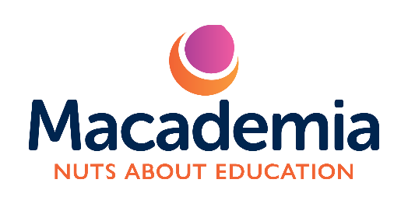

Macademia Pvt Ltd – Terms and Conditions

Last updated: 06/10/2025

These Terms and Conditions (“Terms”) govern all bookings, payments, and participation in courses, workshops, and educational sessions (“Sessions”) provided by Macademia Ltd (“Macademia”, “we”, “our”, or “us”).
By booking or attending a Session, you (“Parent”, “Guardian”, or “Participant”) agree to comply with these Terms.

1. Company Information

Macademia Ltd
Registered in England and Wales
Registered Office: 702 Moor Road, Nottingham, NG6 8TD
Email: info@macademia.co.uk
Phone: 07377 924666

2. Bookings and Payments

2.1. All bookings must be made through our approved booking system or by email confirmation.
2.2. A booking is confirmed only once full payment has been received.
2.3. Payment details and deadlines will be provided in your booking confirmation or invoice.
2.4. We reserve the right to refuse participation if payment has not been made before the Session begins.
2.5. Prices are as advertised and may change from time to time, but changes will not affect confirmed bookings.
2.6. Discounts (e.g., sibling or multi-session discounts) are offered at our discretion and cannot be combined unless stated otherwise.

3. Cancellations and Refunds

3.1. Cancellations made more than 7 days before the start of the booked Session are eligible for a full refund or transfer to another date (subject to availability).
3.2. Cancellations made within 7 days of the Session start date are non-refundable, except in exceptional circumstances at our discretion.
3.3. If Macademia must cancel or postpone a Session, we will offer an alternative date or a full refund.
3.4. Refunds will only be issued to the original payment method.

4. Attendance and Behaviour

4.1. Participants are expected to arrive on time and be collected promptly at the end of each Session.
4.2. Parents/Guardians must ensure that children behave respectfully and follow the tutor’s instructions.
4.3. We reserve the right to refuse continued participation if a child’s behaviour is consistently disruptive or unsafe.
4.4. No refund will be issued in such cases.

5. Safeguarding and Supervision

5.1. All Macademia tutors and staff working with children are DBS-checked, vetted, and appropriately trained.
5.2. Children must be signed in and out by their parent or guardian.
5.3. Parents are not generally required to stay during Sessions unless otherwise specified or agreed.
5.4. We operate in line with UK child safeguarding and health & safety regulations.

6. Health, Safety and Medical Information

6.1. Parents/Guardians must inform us in advance of any medical conditions, allergies, learning needs, or other relevant information about the participant.
6.2. We reserve the right to exclude a participant if health or behavioural information is not disclosed and this poses a risk to safety or welfare.
6.3. In the event of illness or injury, we will take reasonable steps to contact the parent/guardian immediately.
6.4. First aid will be administered by trained staff, and emergency services will be contacted if necessary.

7. Photography and Media

7.1. We occasionally take photos and videos during Sessions for promotional and educational purposes.
7.2. Parents will be asked to provide consent via a media permission form before any child’s image is used publicly.
7.3. Consent can be withdrawn at any time by written notice to info@macademia.co.uk
.

8. Liability

8.1. Macademia Ltd accepts no liability for personal property brought to Sessions.
8.2. While we take every reasonable precaution, we cannot be held liable for accidents or injuries except where caused by our negligence.
8.3. Participation in physical or creative activities carries inherent risks, and by enrolling, parents/guardians accept this.

9. Data Protection

9.1. All personal information is handled in accordance with the UK GDPR and Data Protection Act 2018.
9.2. We only collect and store information necessary for enrolment, safeguarding, and communication purposes.
9.3. We will never share personal data with third parties without consent, except where legally required.

10. Intellectual Property

10.1. All course materials, handouts, and creative content produced by Macademia remain our intellectual property.
10.2. Participants may use these materials for personal learning only and may not reproduce or distribute them without permission.

11. Force Majeure

11.1. Macademia shall not be liable for any failure to perform obligations due to events beyond our control, including but not limited to natural disasters, public health restrictions, or venue closures.

12. Governing Law

12.1. These Terms are governed by and interpreted in accordance with the laws of England and Wales.
12.2. Any disputes will be subject to the exclusive jurisdiction of the courts of England and Wales.

13. Contact Us

If you have any questions or concerns regarding these Terms, please contact us at:
📧 info@macademia.co.uk 07377 924666

