SEND Information Report 2025 – 2026 Hucknall National C of E Primary School
Hucknall National C of E Primary School’s vision and aims:
“Growing together in learning, love and faith”

At Hucknall National C of E Primary School, we aspire to cultivate the gifts and talents of every child and equip them with the wisdom, hope, sense of community and dignity to live life in all its fullness.

Our school’s approach to supporting pupils with SEND:

At our school, we aim to provide every child with access to a broad and balanced education, which includes delivering the National Curriculum in accordance with the Special Educational Needs Code of Practice.

Our aims for the provision for pupils with SEND are:

- To ensure that children with special educational needs or disabilities are educated alongside their peers at a pace and level suited to them.
- To recognise and nurture the individual strengths of all children, fostering the knowledge, skills, and understanding essential for them to reach their full potential.
- To cultivate an environment that promotes self-respect and value for every individual, ensuring a caring and safe atmosphere.
- To encourage children to actively participate in discussions regarding their needs and to consider their perspectives in decision-making processes.
- To work collaboratively with parents, honouring their right to be informed about their child's progress while incorporating their views into the provisions made for their child.
- To empower children to become confident, responsible members of society, prepared for future challenges.

Responsibility for the co-ordination of SEND provision

  - SEND Governor: Elizabeth Szolin-Jones
  - Head Teacher: Sarah Barratt
  - Head of School: Helen Brown
  - Assistant Head Teacher: Samantha Smith
  - SENDCo: Elisia McGregor-Brown

Contact details: office@hnp.snmat.org.uk Telephone: 0115 9632678

Early identification of needs

Our school recognises the importance of early identification and assessment of SEND. A pupil has SEND when their learning difference or disability requires provision that is additional to or different from what is typically available to their peers.

Upon entry, class teachers assess each pupil’s skills and attainment, using information from previous settings where appropriate. While some SEND needs are identified early, others may emerge over time. Staff remain vigilant to any emerging difficulties, value parental insights, and address concerns raised by pupils.
Concerns will be raised if a child’s development:

- Progresses significantly slower than their peers.
- Fails to maintain or improve their rate of progress.
- Does not close the achievement gap with peers.
- Causes the achievement gap to widen.

We follow our school’s own Graduated Approach to ensure all pupils receive the right support, recognising that children learn and progress at different rates. The purpose of formally identifying a pupil with SEND is to ensure effective provision is in place to reduce or remove barriers to learning.

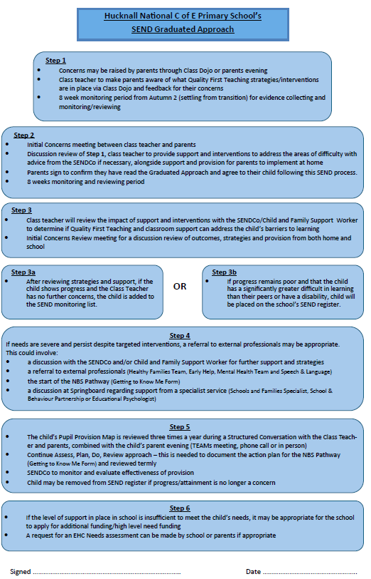

Quality First Teaching and Inclusive Provision

Our class teachers are committed to ensuring that every pupil, including those with SEND, can succeed by delivering Quality First Teaching and making appropriate adaptations to the environment, curriculum and expectations. Class teachers will ensure that every child can succeed by:

- Making appropriate adaptations to the classroom environment, curriculum content and expectations to remove barriers to learning.
- Using Quality First Teaching strategies, supported by teaching assistants, to provide engaging and inclusive learning opportunities for all pupils.
- Adapting tasks and resources to reflect pupils’ individual starting points, strengths and areas for development.
- Using ongoing assessment and observation to inform planning and to adjust teaching promptly where necessary.
- Providing clear explanations, modelling and scaffolding to support understanding and independence.
- Using a range of communication methods (visual, verbal, practical) to meet diverse learning styles.
- Incorporating opportunities for overlearning, reinforcement and retrieval to secure progress.
- Building positive relationships and high expectations to promote pupils’ confidence, motivation and resilience.
- Liaising regularly with the SENDCO and other professionals to seek advice and implement recommended strategies.
- Communicating with parents/carers to share information on their child’s learning and progress.

Together, these approaches form the foundation of our school’s SEND provision, ensuring that pupils’ individual needs are recognised early and that inclusive, high-quality learning experiences are embedded across the curriculum.

Working with Support Services and External Professionals

Hucknall National C of E Primary School actively seeks advice and support from external agencies in the identification, assessment and provision for pupils with SEND. The school employs a Child and Family Support Worker to act as a link between home and school, providing targeted support for families in a variety of ways. This may include attending medical appointments alongside parents or delivering workshops to support parental engagement.

Termly multi-agency meetings, known as Springboard meetings, are held to review and plan the support required for individual pupils. The SENDCo is the designated lead for liaising with a range of external professionals and services, including:

- Educational Psychology Service
- Chatter SALT
- SBAP / SEMH Support
- Social Care
- Speech and Language Service
- Schools and Families Support Services
- Community Paediatrician
- Physical Disability Support Service
- Occupational Therapists
- Multi-Agency Teams, including Virtual Schools (LAC), Social Services, CAMHS, Bereavement Counselling, Early Help Assessment Meetings (EHAF), and the Multi-Agency Support Hub (MASH)

This collaborative approach ensures that pupils’ individual needs are identified promptly and that appropriate, specialist support is coordinated effectively to promote their well-being and educational progress.

Parental Engagement
At Hucknall National C of E Primary School, we believe that a strong partnership with parents and carers is essential to support pupils with SEND. Close collaboration helps to ensure:
- Early and accurate identification and assessment of SEND, leading to appropriate intervention and provision.
- Ongoing social and academic progress for pupils with SEND.
- Personal and academic targets are set and achieved effectively.
Parents and carers are kept informed about their child’s development through regular termly progress review meetings, referred to as Structured Conversations. Where closer or more frequent communication is required, arrangements will be made according to the specific needs of each pupil. This approach ensures that parents are actively involved in their child’s education, well-being, and overall progress.
Monitoring and Evaluating SEND Provision
At Hucknall National C of E Primary School, we regularly monitor and evaluate the effectiveness of our SEND provision to ensure that all pupils make strong progress. This includes:
- Tracking Pupil Progress: Class teachers use ongoing assessments, termly progress reviews, and Structured Conversations to monitor academic, social, and emotional development. Data is reviewed to identify pupils who are not making expected progress towards their own targets and to adapt support accordingly.
- Measuring Intervention Impact: All SEND interventions are carefully monitored. The SENDCo evaluates the impact of additional support programs, including one-to-one and small group interventions, to ensure they effectively remove barriers to learning.
- Use of PIVATS: For pupils working below their key stage expectations, we use PIVATS (Performance Indicators for Value Added Targets) to assess small steps of progress, set achievable targets, and track their development over time.
- Pupil Voice: Pupils with SEND are encouraged to share their views on the support they receive. Their feedback is used to adapt teaching, resources, and interventions to better meet their needs.
- Parental Feedback: Parents and carers provide feedback during Structured Conversations and through other communication channels. Their input helps to refine provision and ensures that the support aligns with home and school priorities.
- External Review: The SENDCo works with external professionals and agencies to review the effectiveness of Pupil Provision Maps and to adjust provision based on specialist

Nottinghamshire’s Local Offer
Hucknall National C of E Primary School recognises the importance of providing parents and carers with access to reliable information and support regarding SEND.
The SEND Local Offer is a comprehensive resource designed to support children and young people with special educational needs and/or disabilities and their families. It provides information about services available across education, health, and social care, as well as services offered by the private, voluntary, and community sectors. More information can be found at: Nottinghamshire SEND Local Offer.
Further support is available through Nottinghamshire’s free and confidential Information, Advice and Support Service, ‘Ask Us’, which provides guidance and advocacy for families of children with SEND. More information can be accessed here: Ask Us Nottinghamshire

Continuing Professional Development (CPD)

All staff are kept up to date with relevant training and developments in teaching practice in relation to the needs of pupils
with SEND. The SENDCo attends relevant SEN courses, Family SEN meetings and facilitates/signposts relevant SEN focused
on external training opportunities for all staff.

Recent or ongoing training includes:

- Controlling Risky Behaviours
- Emotion Coaching
- Building resilience in children and those who support them.
- Take Five
- Using mindfulness with children and young people
- Understanding and working with anxiety in children and young people

Transition

At Hucknall National C of E Primary, we recognise the importance of smooth transitions for children with SEND. We work closely with local childcare providers to gather key information about new pupils and have structured procedures in place to support internal transitions between year groups.

For the transition from KS2 to KS3, Year 6 staff collaborate with the receiving secondary school’s SENDCo and Year 7 team to share detailed records, including Pupil Provision Maps. Key staff from the secondary school may attend review meetings up to a year in advance, and additional transition visits or sessions can be arranged as needed. Parents are also encouraged to meet with the secondary school’s SENDCo to discuss any concerns.

School Trips and Activities

When planning activities outside the classroom, teachers consider the needs of SEND pupils to ensure inclusivity. School visit locations are carefully selected, and risk assessments are conducted to address transport, accessibility, medical, and sensory needs. Staff may carry out pre-visits, and parents/carers are consulted to ensure appropriate arrangements.

Evaluating Effectiveness

The effectiveness of SEND provision is regularly reviewed by the Head Teacher, Senior Leadership Team (SLT), and SEND governor as part of the school’s quality assurance cycle. Parent and pupil feedback is gathered through termly review meetings and pupil voice activities to assess the impact of support provided.

Handling Complaints

We value parental feedback and encourage open communication. If parents have concerns about their child's SEND support, they should first speak with the class teacher or SENDCo. If issues remain unresolved, they can escalate concerns to the Head Teacher. Further information is available in the SNMAT Complaints Policy on the school’s website.

