Sir Edmund Hillary Academy

SEND Information Report
2026-2027

Our School  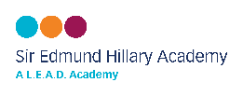 | Our Vision:  At Sir Edmund Hillary Academy our vision is to create a happy, safe, and inclusive learning environment that celebrates diversity and values community. We aim for our children to be courageous, confident, and curious learners who are resilient, hardworking, and achieve their full potential. For those children with additional needs or with a disability, we want them to feel that they are a valued part of our school community and that they belong. We respect that children with SEND may:  - Have different educational and personal needs to their peers  - Need additional or different strategies for learning  - Make progress at different rates and in different ways  - Need a range of adaptive teaching  We aim to remove barriers and encourage all our pupils to achieve to the best of their abilities through quality first teaching in a supportive and caring environment. Where learners require additional to, or different from the universal provision available, we are committed to ensure that the needs of all learners are met.  September 2026 Information  We currently have 296 children on role (September 2025)  There are currently 53 children on SEND register with a range of needs from universal to specialist.  6 children that have an EHCP (2%) and 10 children have AFN funding in place (3.4%).  Currently, the breakdown our SEND needs in school, according to Area of Need is:  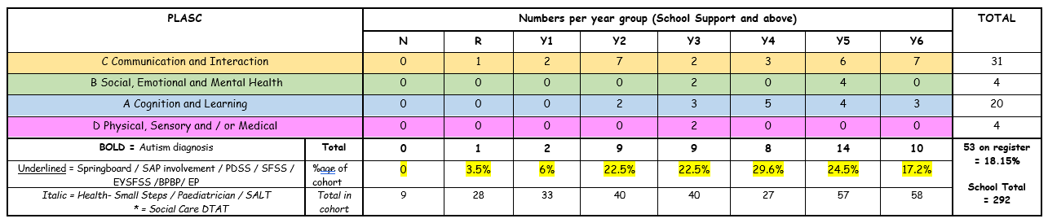
  Special  Educational  Needs | At Sir Edmund Hillary Academy we support children with a variety of differing special educational needs and we pride ourselves on being a highly inclusive school with an ethos which encourages and celebrates diversity and difference.  SEND is categorised into the following areas in the SEN code of practise 2014:
   | Cognition and Learning
   | Communication and Interaction
   | Social, Emotional and Mental Health
   | Physical, Sensory and / or Medical
  Meet our SENDCO | The SENDCO is Mrs Wingfield  If you would like to contact Mrs Newton, please call school on 01909 473982 or you can send an email to office@siredmundhillaryacademy.co.uk which will be forwarded on to her.

  Identifying and  Assessing Need | At Sir Edmund Hillary Academy we work closely as a team and if staff have a concern about a child’s learning or progress, they can fill out a SEND Concern Form. If the class teacher has any concerns about your child, they will talk to you as parents and together you can decide what might help your child to make progress. Your child will then be monitored and teachers will make adaptations during lessons in order to support their needs.  After a term, or possibly two, we will decide if your child needs to be placed on the SEND register (if their attainment or progress is still a concern). If this is the case you will be invited to a meeting, where we can talk about the targets your child may need to work on, how they will be supported in class and what you can do to help at home.  We use the Assess, Plan, Do, Review cycle to support children with SEND needs:  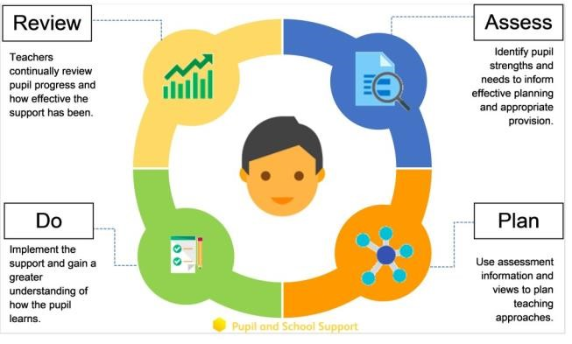
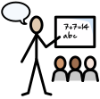  Our approach to teaching  children with  SEND | We are an inclusive school. Wherever possible children are taught alongside their peers in flexible teaching groups.  Teachers adapt their high-quality teaching to cater for their pupils’ needs and plan individual timetables where necessary. When appropriate, staff are deployed to give children additional interventions in small groups outside the classroom, or to provide one-to-one support.  We use the Ordinarily Available Provision guidance produced by the Local Authority to complement our teaching.  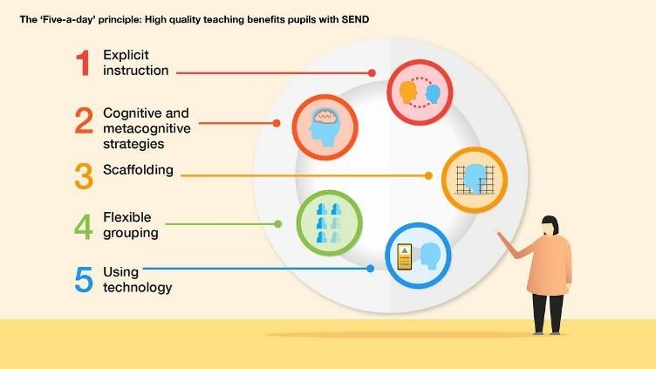  We use the EEF guidance ‘Five-a-day’ and embed the key principles into all our lessons.

  Curriculum adaptations | We use a range of strategies across our lessons to ensure we offer an inclusive approach to learning and allow all children to access the classroom environment.  We also seek advice and equipment from outside agencies as and when the need arises.
  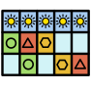 |  | 
  Visual timetables | Task boards | Peer mentoring
   |  | 
  Assistive technology | Talk partners | Peer marking
   | 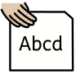 | 
  Self-assessment | Word banks | Positive behaviour
   |  | 
  Ear defenders | Timers | Explicit instruction
  Parent  Consultations | At Sir Edmund Hillary Academy we work closely with parents and carers and recognise that they have much to contribute to our support for children with SEND.  We hold drop-in sessions every term and Mrs Wingfield is available at parents’ evenings to discuss any concerns.  For children who are on the SEND Register, we will invite you to 3 further meetings a year in the Autumn, Spring and Summer term. These meeting are used to celebrate your child’s learning, looking at the progress they have made, create new targets and discuss next steps. A copy of this will always be sent home after the meetings.  During the year a parental questionnaire is sent out to gain views on the school and the SEND provision.

Child  Consultations | Pupil’s views are very important; they have a right to be involved in decisions about their education and they are made aware of the support that surrounds them in school.  Children’s views feed directly into policies, school procedures and daily teaching of children with SEND.  Pupils are given opportunities to:
   |  | 
  Self-assess how they are doing | Attend meetings and help decide the support needed. | Feedback and Review progress/interventions.
  Evaluating  Provision | At SEH Academy we spend significant amounts of time reviewing and monitoring our provision:  We discuss and share ideas in staff meetings to ensure up to date research and policy is in place.  We review children’s individual progress towards their goals at regular intervals, as a minimum every term.  We establish children’s baseline before beginning interventions and review the impact of interventions at regular intervals.  We ask our children if they feel the adjustment or intervention is helpful and makes a difference.  Provision is regularly monitored by the SENDCO.  We regularly use tracking tools to update targets and measure progress.  We hold yearly reviews for children who have Education Health and Care Plans, or every 6 months for children who are in EYFS.
  Staff Training | At Sir Edmund Hillary Academy, we believe in professional development and aim to ensure all our staff have the understanding they need to enable them to support your child.  When a new member of staff joins the school, we ensure they understand the systems within school and they are given information about the children they are working with.  The senior leadership team within school are constantly moderating needs within the school and, where an area of concern is highlighted, whole school training could be organised to ensure all staff understand specific learning difficulties and appropriate teaching or support strategies that could be utilised.

